**Sequences Practice Problems**

1. Use Random Function (( RANDOM )) to get Single Digit .

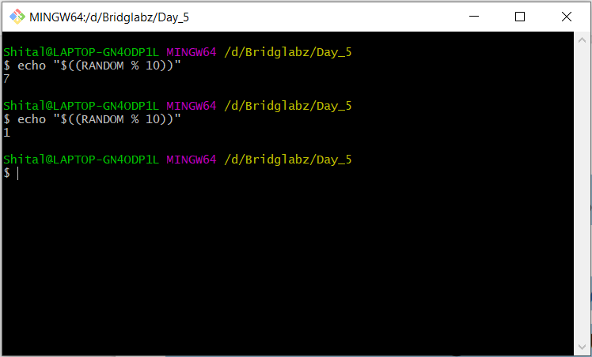

2. Use Random to get Dice Number between 1 to 6 .

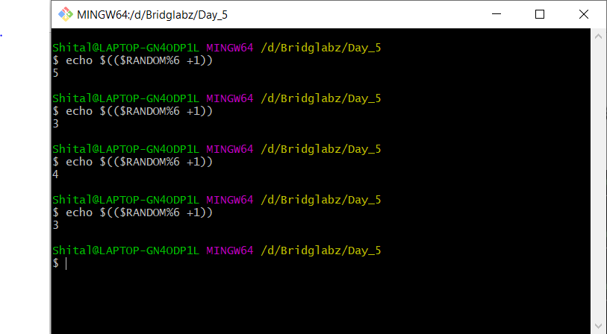

1. Add two Random Dice Number and Print the Result.

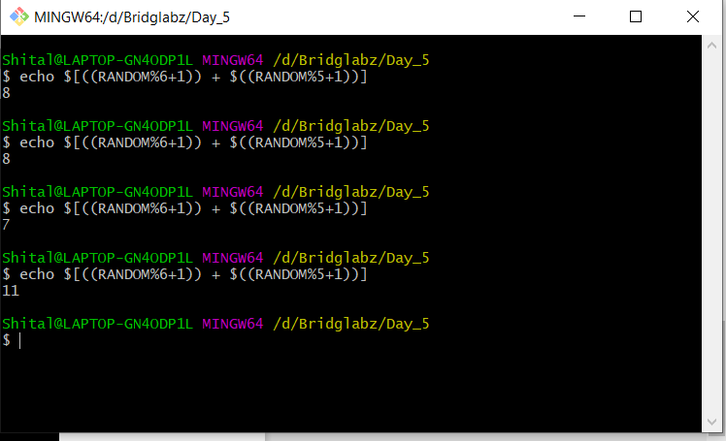

1. Write a program that reads 5 Random 2 Digit values , then find their sum and the average .

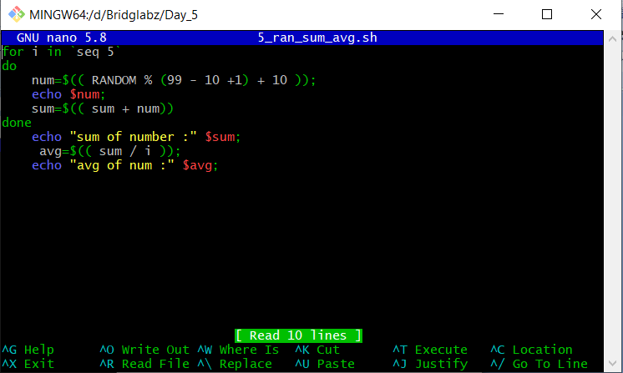

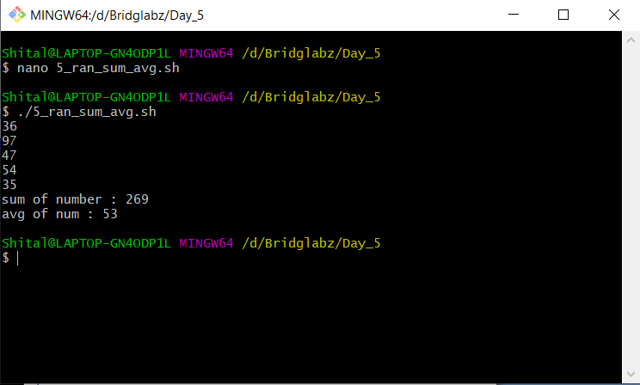

5. Unit Conversion

a. 1ft = 12 in then 42 in = ? ft

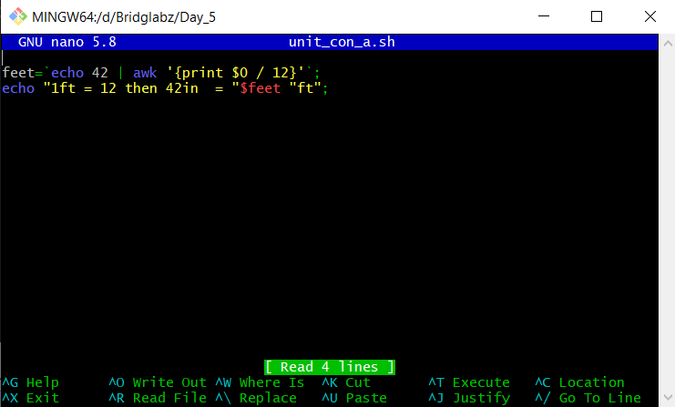

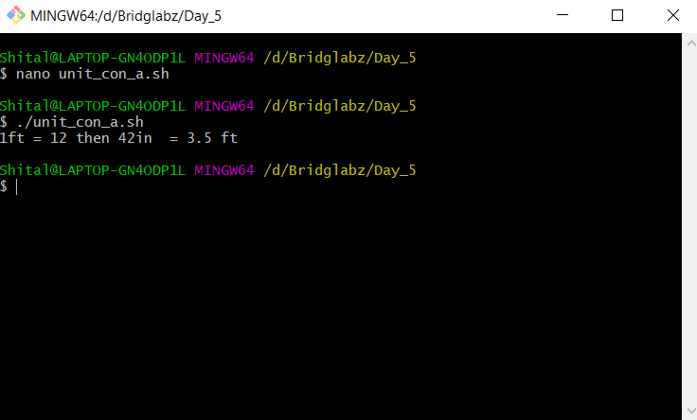

b. Rectangular Plot of 60 feet x 40 feet in meter.

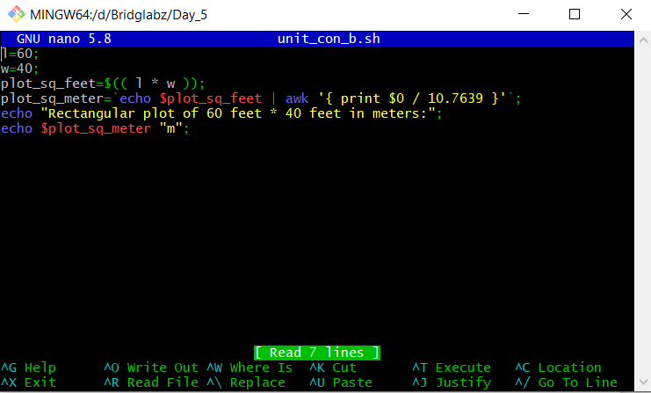

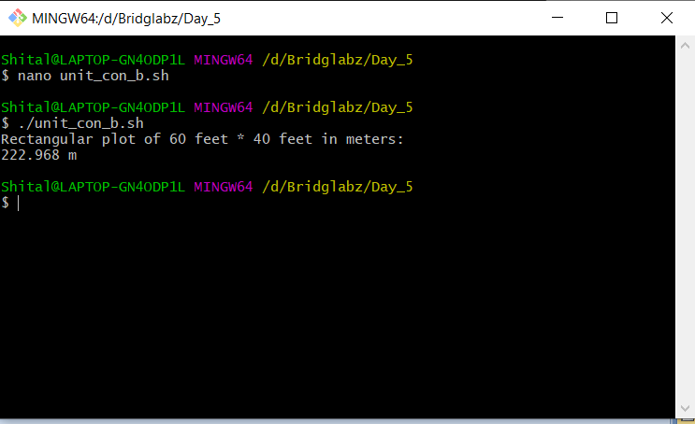

c. Calculate area of 25 such plots in acres.

